**Setting up OAuth2 with Azure**

Register your application (XI server)

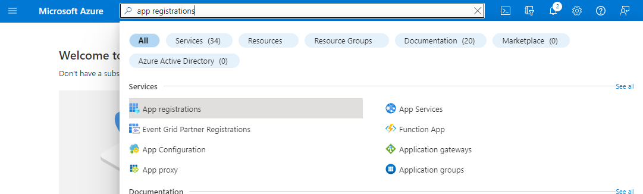

* Register an application

* Create a new Registration and copy your Redirect URI from the Nagios XI OAuth2 configuration page into the app registration form.

Get your OAuth2 credentials

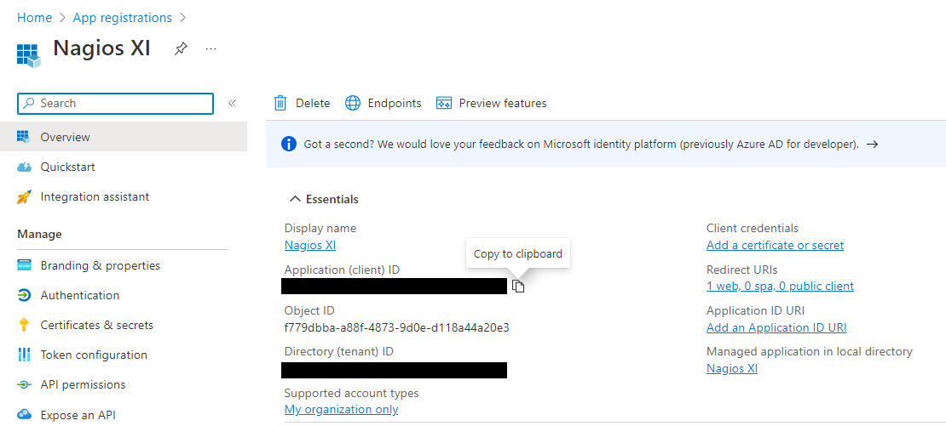

* Copy your Client and Tenant IDs to the Nagios XI OAuth2 configuration page
* Add a certificate or secret

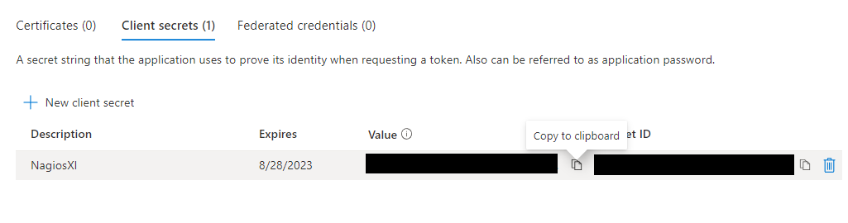

* New client secret -> Add -> copy the value of the secret

Give your XI Server permission to send mail

* API permissions -> Add a permission

* Select Microsoft Graph

* Under “Delegated Permissions” select Mail.Send and offline_access

Note: you may remove Azure’s default User.Read permission

You may now return to your Nagios XI OAuth2 configuration page and submit the form.

Microsoft will now ask you to sign in and give permission for NagiosXI to send mail on your behalf.

* Consent on behalf of your organization

Note: The permissions shown will vary depending on which API permissions you have configured.

Once done, it will redirect you to the aforementioned Redirect URI which should be the same NagiosXI OAuth2 configuration page. It will then tell you that your OAuth2 has been configured and that you may return to your XI server.

Note: If you are completing this process on a browser outside of your XI server (WE DO NOT RECOMMEND THIS and this should only be done if necessary), then you will need to replace localhost in your browser’s URL with the IP address of your XI server.





Note: If your XI server has a valid DNS name, you may replace localhost from your Redirect URI with the DNS name of your XI server.